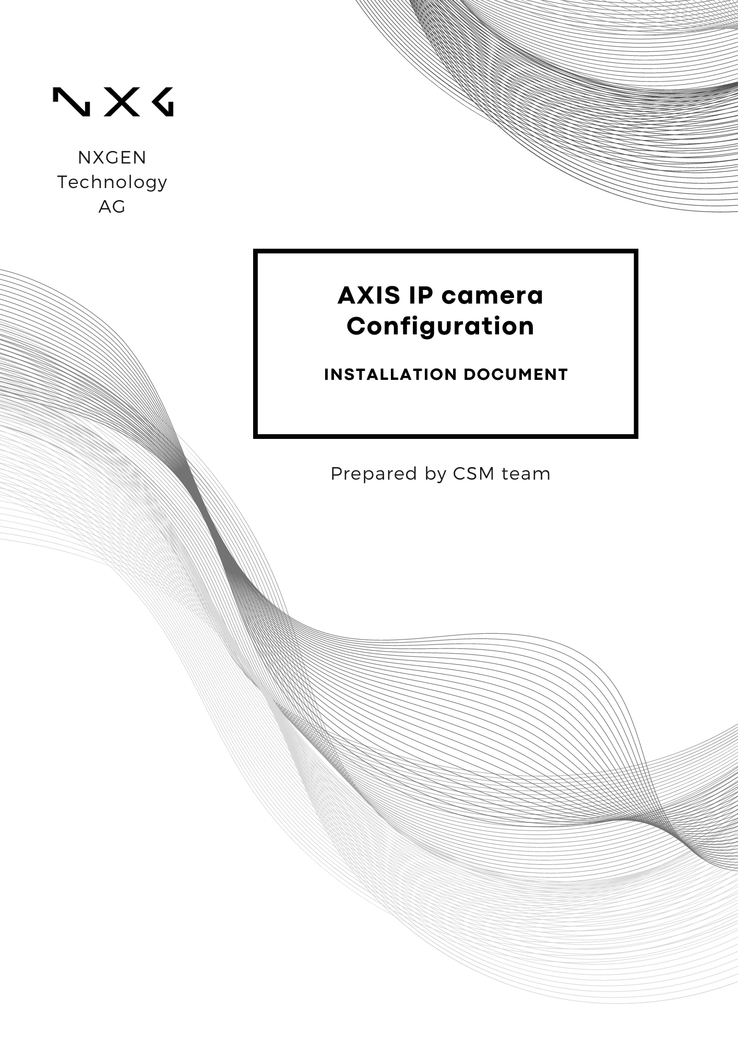

Disclaimer:
This document is provided under NXGEN Technology Ltd's (NXGEN) General Terms & Conditions.
https://www.nxgen.io/en/gtc/

Intellectual Property and Copyright:
All content, including but not limited to text, graphics, logos, images, audio clips, and software, available on NXGEN's platforms and services is the intellectual property of NXGEN or its licensors and is protected by copyright laws. Unauthorized reproduction, distribution, or modification of any content without prior written consent from NXGEN is strictly prohibited. Users are granted limited, non-exclusive, and revocable permission to access and use the content for personal or internal business purposes only. Any misuse or infringement of NXGEN's intellectual property rights will be subject to legal action.

https://www.nxgen.io/

Table of Contents
Disclaimer: 2
Introduction: 4
Prerequisites: 4
Setting up a User Name and password for NXGEN team: 5
Axis IP Camera Configuration Guide with GCX-ONE 7
Configurations on Axis IP Camera: 12

Introduction:
This document is designed to guide you through the process of configuring AXIS IP cameras to ensure optimal performance and security within your surveillance system. Whether you are a system administrator, security professional, or IT specialist, this guide will provide you with the necessary steps and information to integrate AXIS IP cameras effectively into your network.
If any issues arise with the configuration, please raise a ticket through NXGEN’s Help Desk portal to the NXGEN support team for swift issue resolution.
Alternatively, refer to Axis communications knowledgebase.

Prerequisites:
Before you begin the configuration process, ensure the following prerequisites are met:
- Site Configuration: The site where the device will be added is already configured in GCX-ONE.
- Set up a user: An admin user with the necessary permissions is configured.
- Control Port: The control port is open (default is 80, unless changed).

Setting up a User Name and password for NXGEN team:
Step 1: Log in to the AXIS IP Camera.
- Open your web browser and enter the IP address of the Axis Camera into the URL bar.
- Press "Enter" to navigate to the camera's login page.
- Enter your username and password.
- Click "Login" to access the camera’s settings.
Step 2: Navigate to User Management.
- Once logged in, go to the main menu.
- Navigate to System.
- Select Users to manage the user settings for the Axis Camera.
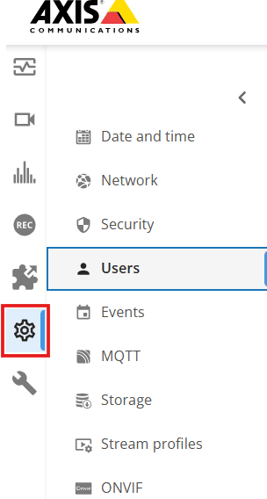

Step 3: Navigate to "Add User", and then add the credentials needed for NXGEN to log in to the Software with Admin or Viewer permission.
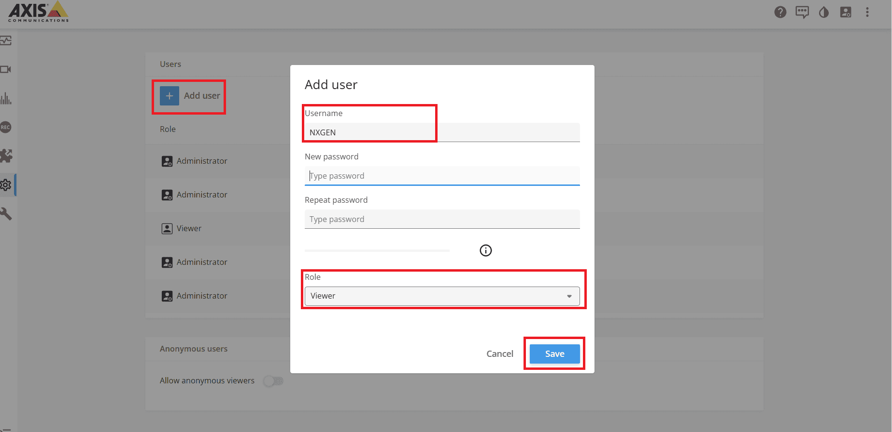
Referring to the AXIS IP camera document, the difference between each role is as mentioned below:
Administrator: The Administrator role grants full access to the entire system, including automatic access to all cameras, I/O ports and views. Therefore, you do not need to specify any camera, I/O or view privileges for a user with this role. This role is required to configure the system.
Operator: An Operator has access to live and recorded video of selected cameras and access to selected I/O ports and views. An operator has full access to all functionality of AXIS IP Camera except system configuration.
Viewer: A viewer has access to live video of selected cameras and access to selected I/O ports and views. A viewer does not have access to recorded video or system configuration.

Axis IP Camera Configuration Guide with GCX-ONE
Step 1: Log in to GCX-ONE.
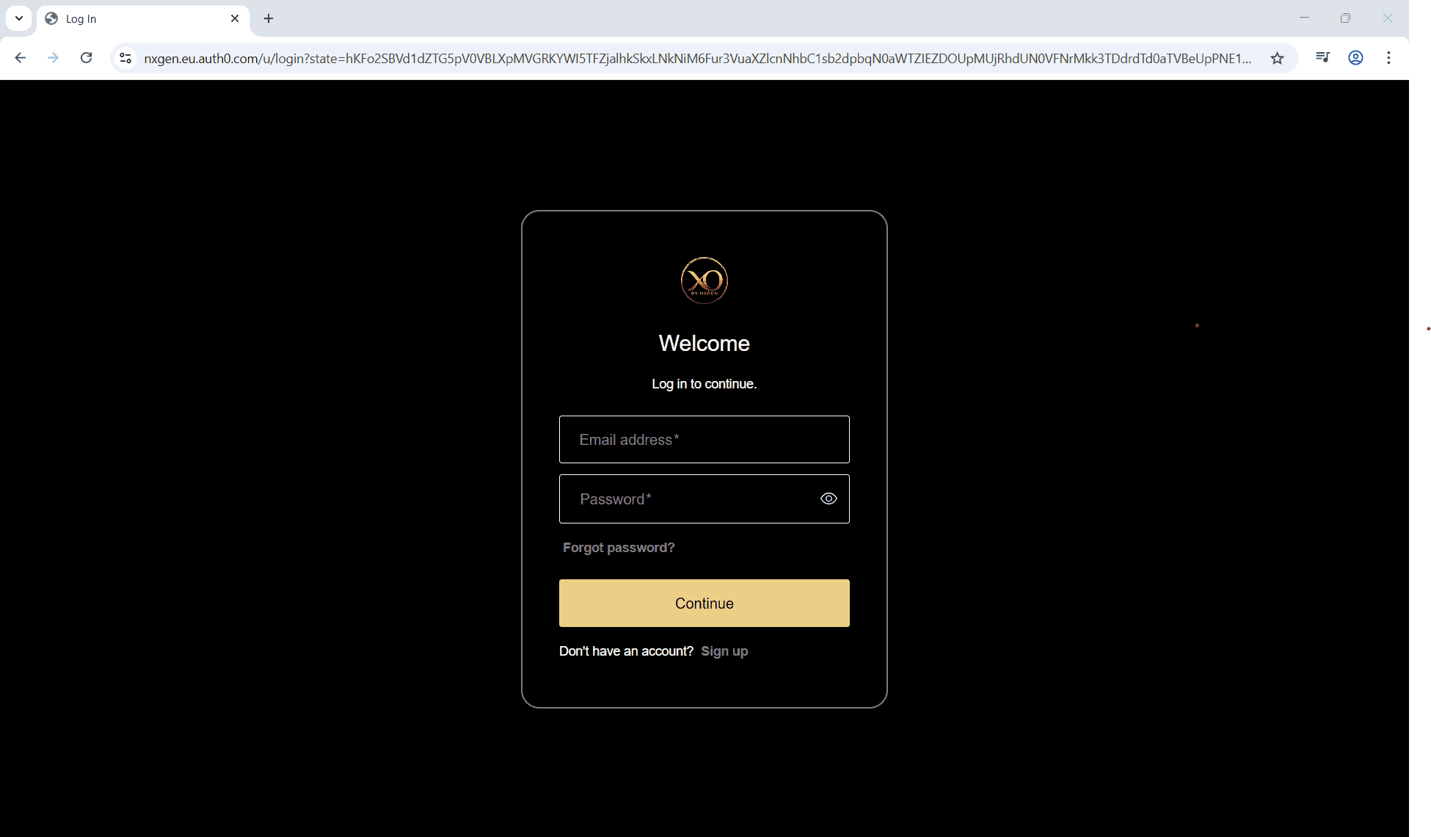
Step 2: Click on the Configuration menu.
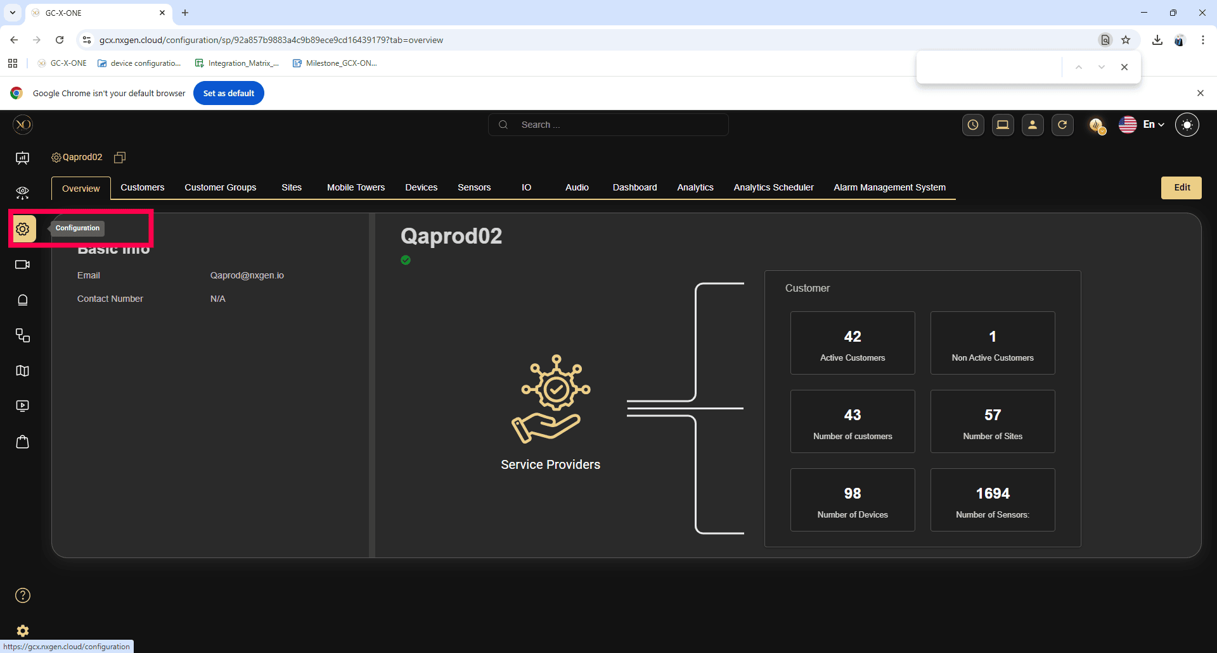
Proceed to add and configure your AXIS IP Camera.

Step 3: Navigate to the Sites tab, where the Axis Camera is to be added.
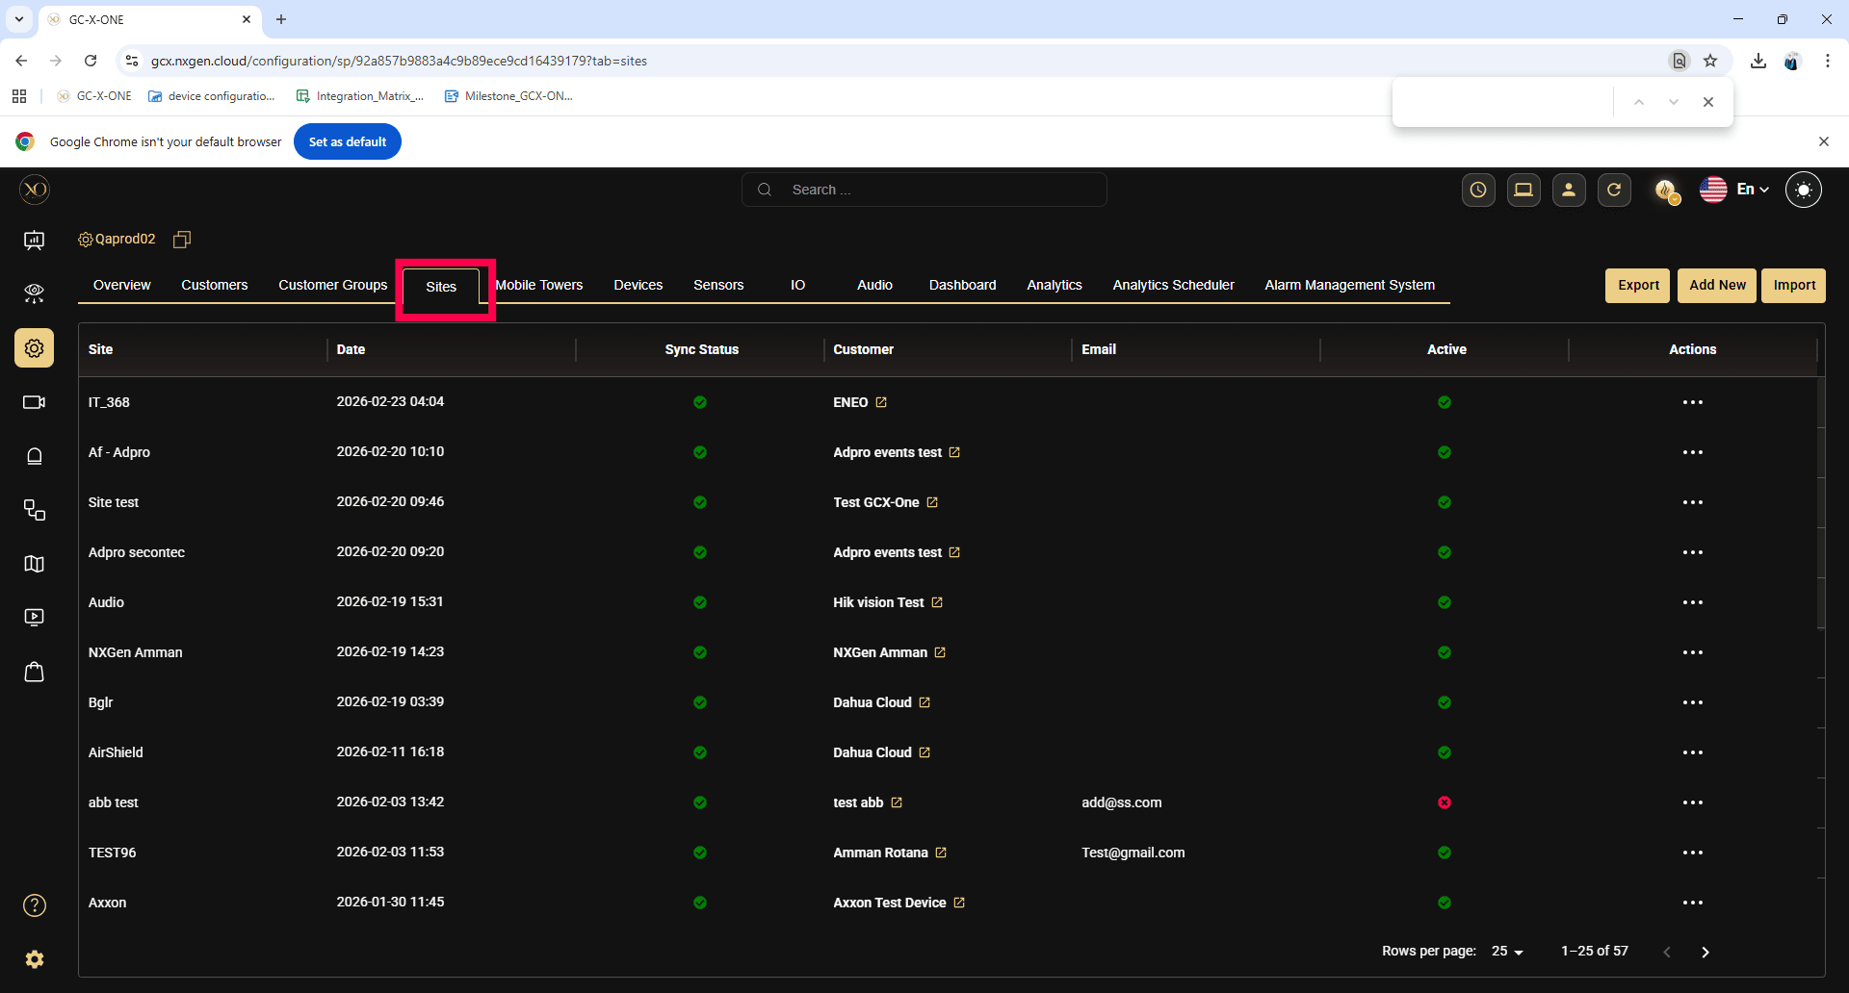
Step 4: Navigate to the Devices tab to view and manage the devices associated with the selected site.
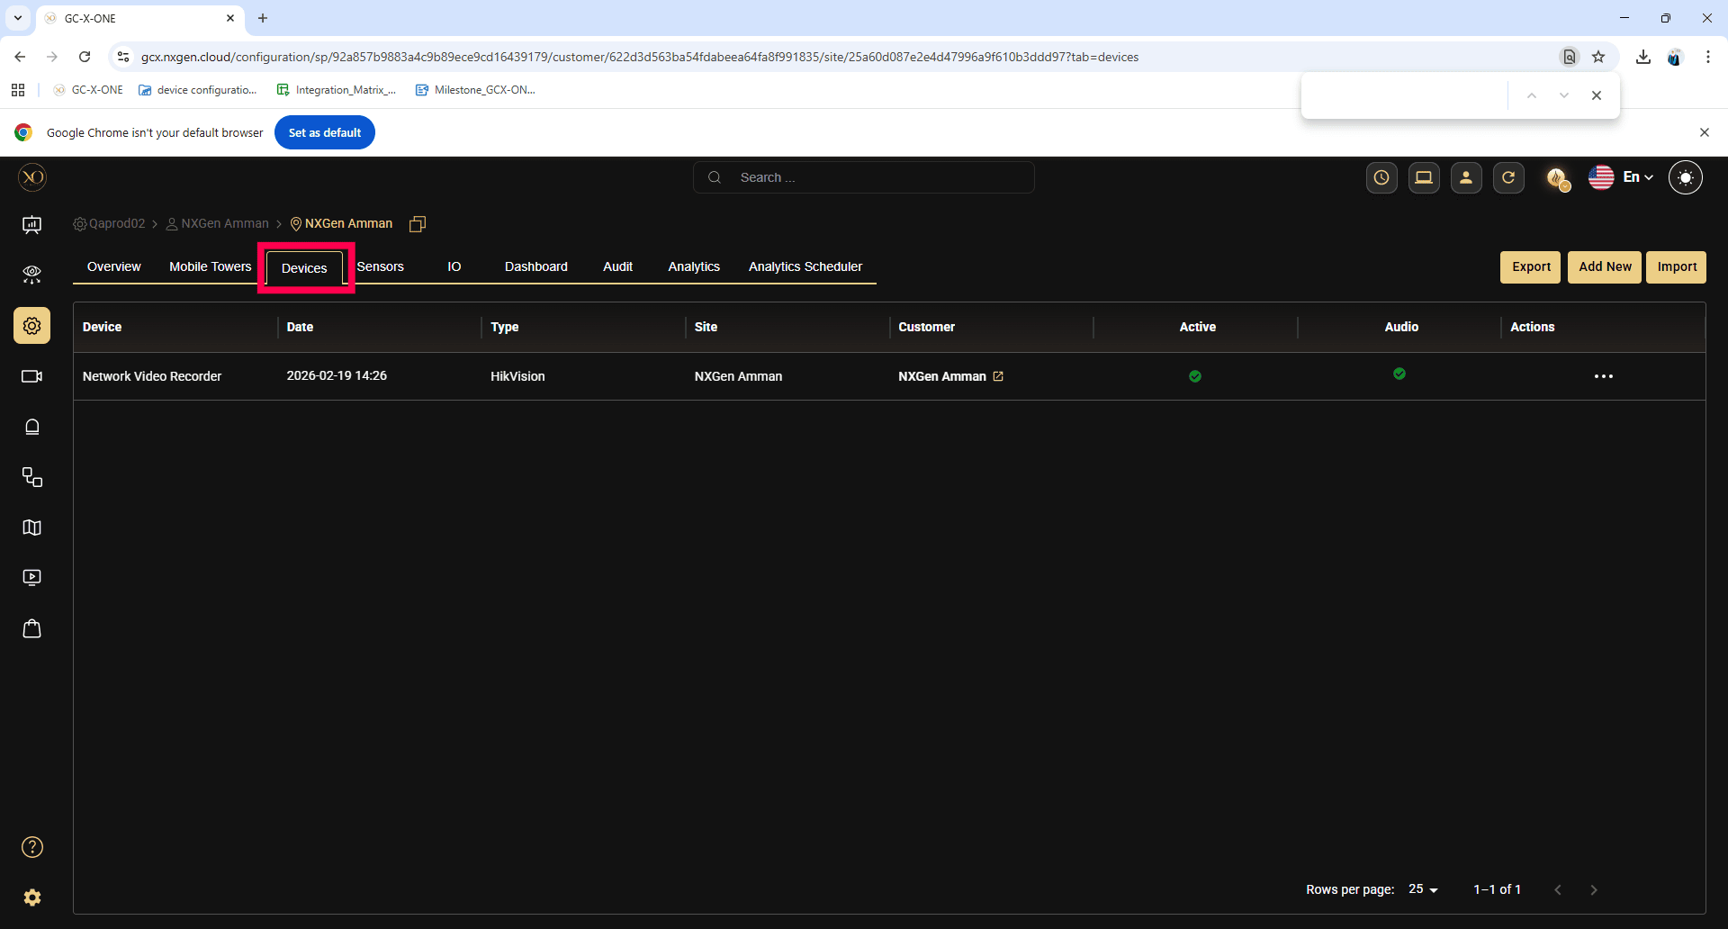

Step 5: Click the Add button.
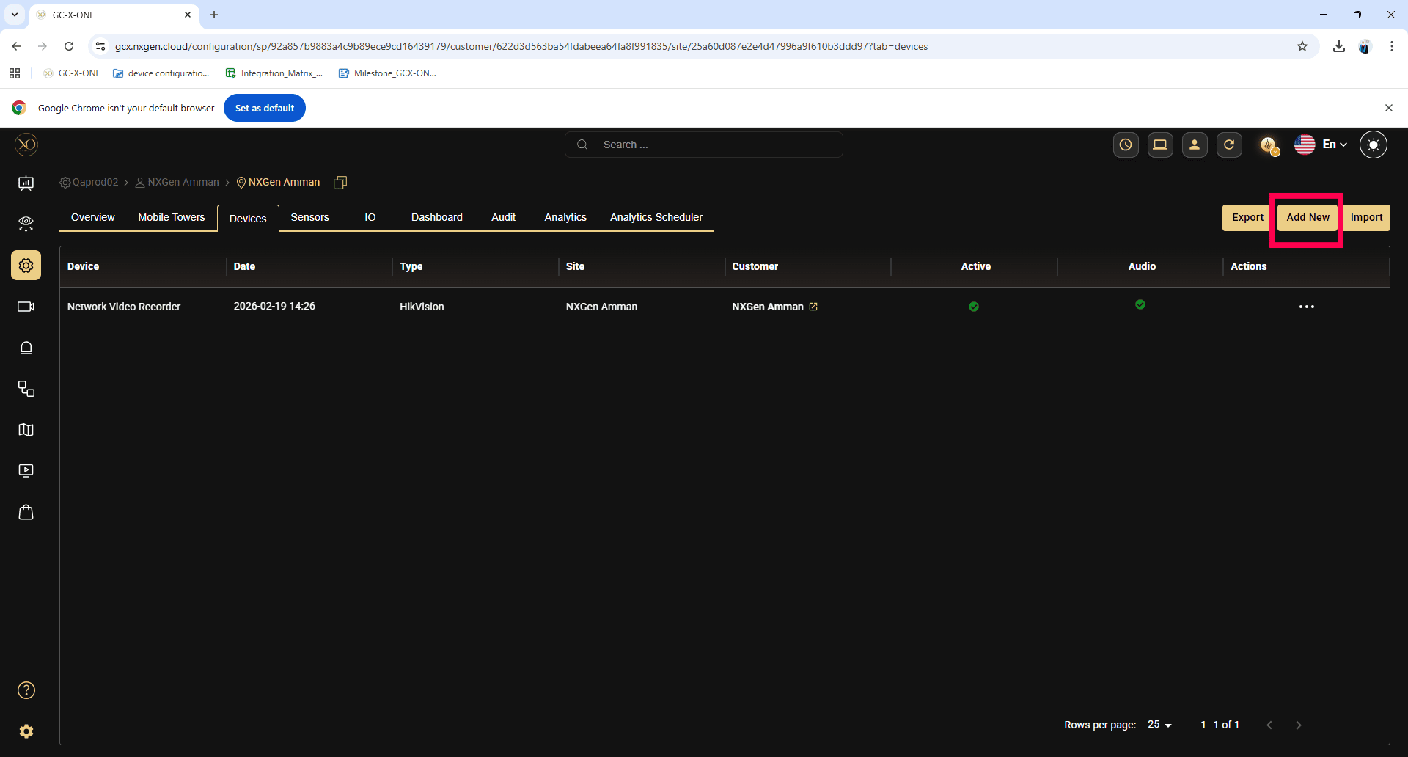

Step 6: In the dialog, open the Device dropdown and select Axis
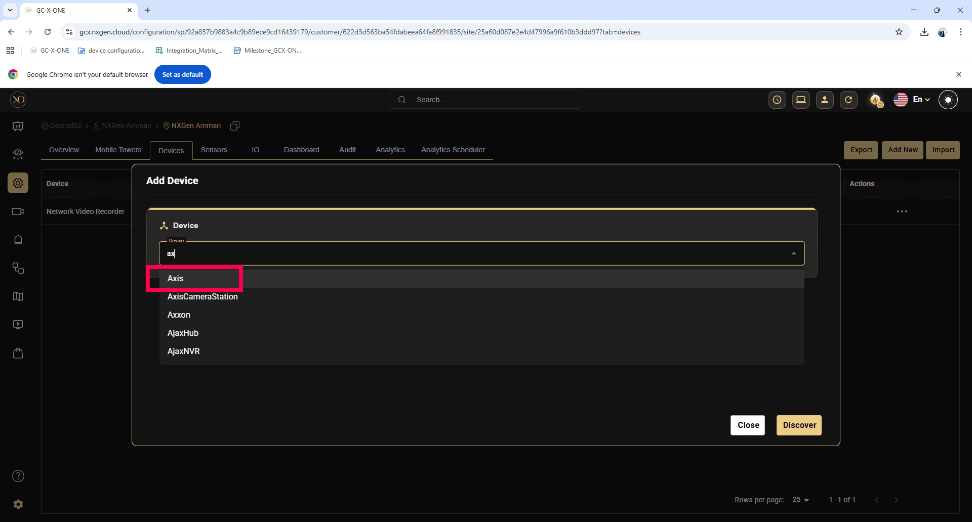
Step 7: Enter all required fields:
- Name
- IP Address or Host
- Username
- Password
- Control port
- RTSP Port
- Server port
- Https Port
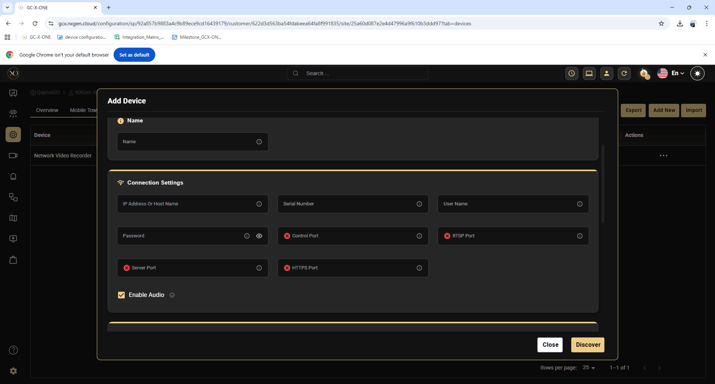
The Control Port defaults to 80 if no value is entered. Ensure that this port is open on your firewall.

Step 8: Click Discover.
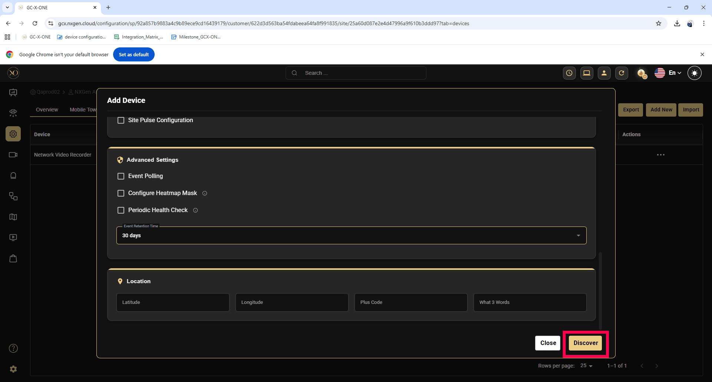
Step 9: Once the device is successfully discovered, click Save.
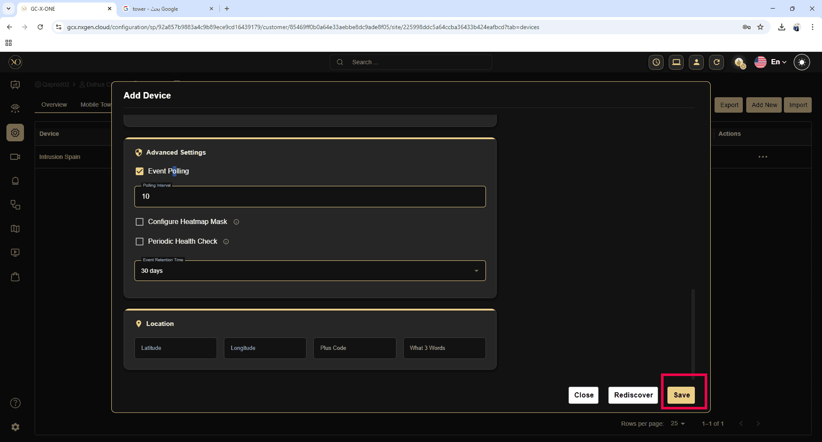

Step 10: Note the NxgenDeviceId from the Unique Reference Number:
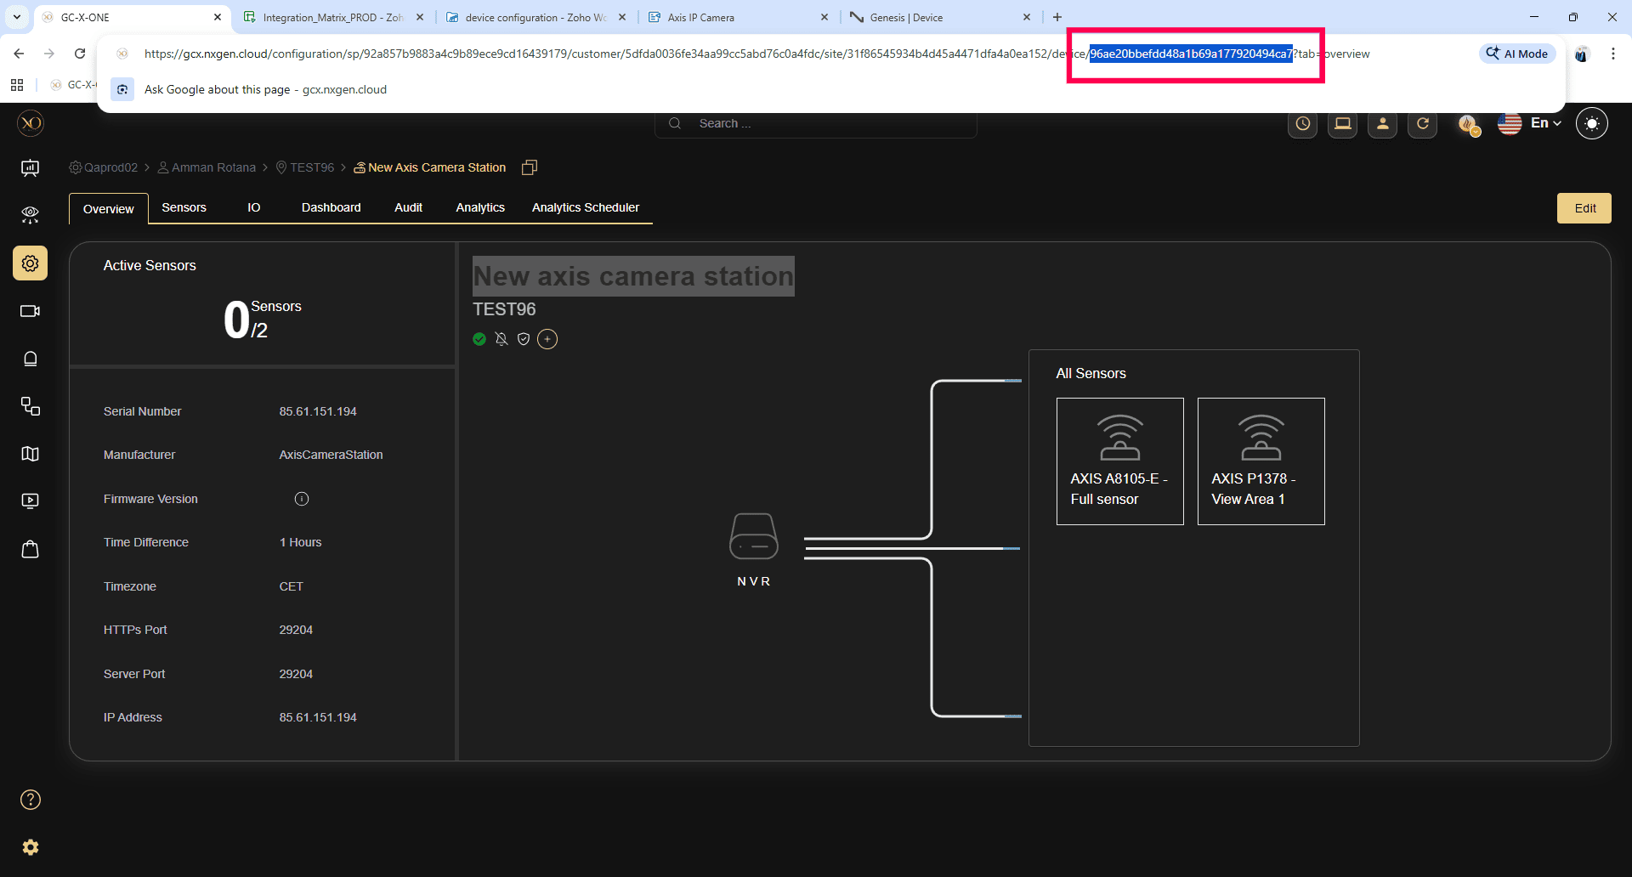

Configurations on Axis IP Camera:
Step 1: Log in to the AXIS camera.
- Open your web browser and enter the IP address of the Axis Camera into the URL bar.
- Press "Enter" to navigate to the camera's login page.
- Enter your username and password.
- Click "Login" to access the camera’s settings.

Step 2: Navigate to Event Management.
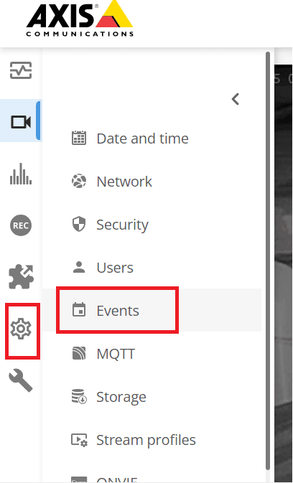
Step 3: Navigate to Recipients tab and Add recipient.
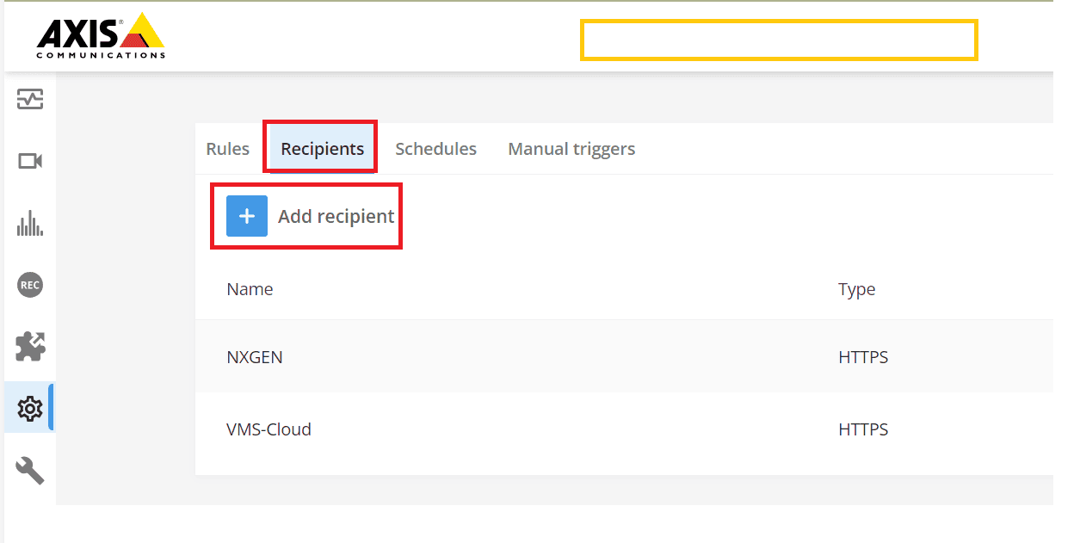

Step 4: Enter the details for the recipient as follows and Save. The recipient will be added to the list.
- Name : Any name you choose.
- Type: HTTPS.
- URL: https://axisproxy.nxgen.cloud/eventIngest/<nxgenDeviceId>
- User Name: < nxgenDeviceId >
- Password: < nxgenDeviceId >
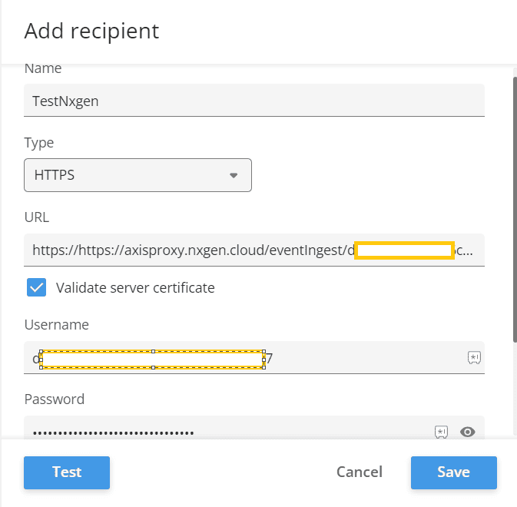
Step 5: Configure Rules:
- Navigate to the Rules tab and add a rule.
- Create a rule for each event type that must be notified to GCX-ONE.

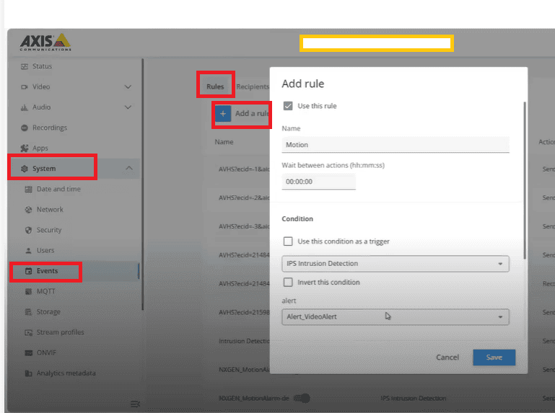
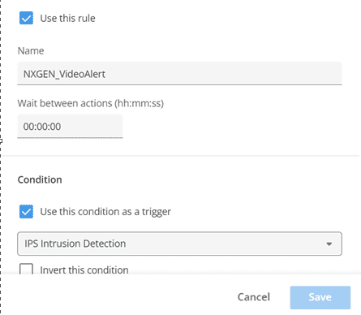
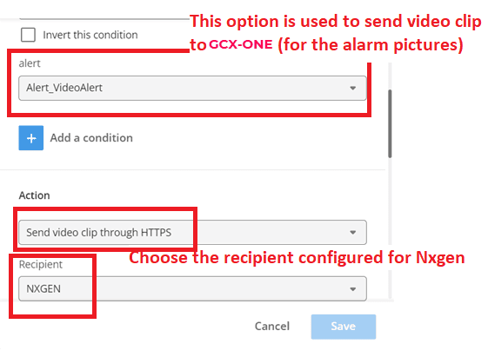
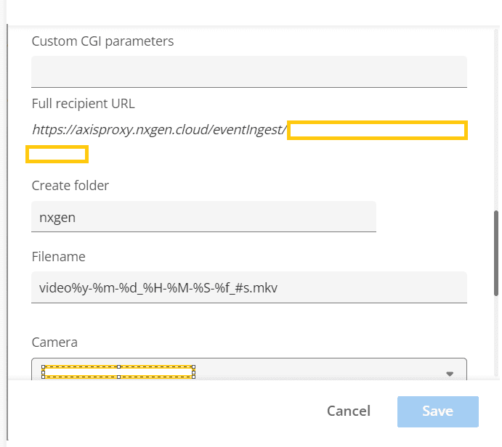
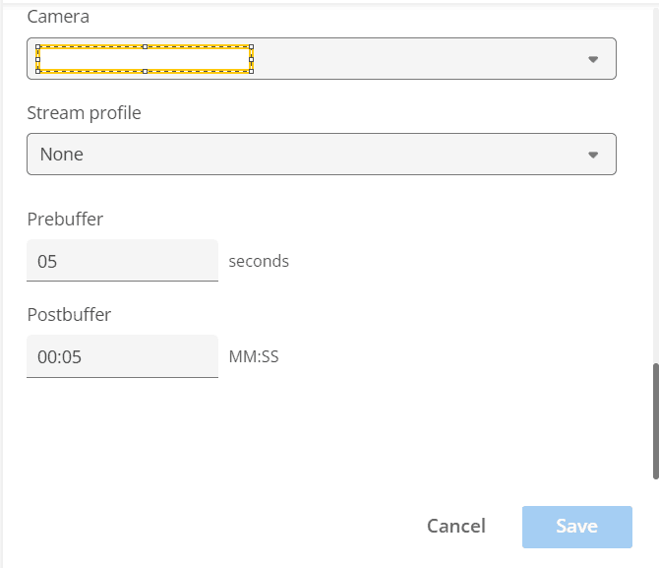
These steps will help you have the Axis IP camera integrated into the GCX-ONE system, allowing you to manage events, configure alerts, and ensure the camera is properly monitored within your security infrastructure. By following these instructions, you will ensure seamless operation and enhanced security through effective event management.

